|  |  |  |  |  |  |  |  |  |
| --- | --- | --- | --- | --- | --- | --- | --- | --- |
|  |  | |  | | |  |  | |
|  |  | |  | | |  |  | |
|  | | | | | | | | |
| http://4.bp.blogspot.com/-SotLIkzmscA/UqQLE9BjdPI/AAAAAAAAARc/-SF46qFfVE0/s1600/daffodil-international-university-logo.png  Bachelor Project | | | | | | | | |
|  | | | | | | | | |
| PROJECT TITLE  Address Book System(ABS) | | | | | | | | |
|  | | NAME: Saiful Islam | |  | ID: 151-35-865 | | |  |
| NAME: | |  | ID: | | |
| Supervisor Name | | ： | Md. Alamgir Kabir | | |
| Department: | | ： | Software Engineering | | |
| Faculty of Science and Information Technology | | | | | |
|  | |  |  | | |
| December 2017 | | | | | | | | |

Table of Contents

Chapter 1 5

1. Introduction 6

1.1 About the System 6

1.2 Purpose 6

1.3 Scope 5

1.4 Vision 7

1.5 Why this system is necessary? 7

1.6 Proposed Solution 7

Chapter 2 8

2. System Analysis 9

2.1 Use Case Model 9

2.2 Actor Goal List 9

2.3 Use Case Description (Brief) 10

2.3.1 Reach Peoples 10

2.3.2 Settle up Information 11

2.3.3 Handle Address Book 12

2.4 System Sequence Diagrams 13

2.4.1 Reach Peoples 13

2.4.2 Settle up Information 14

2.4.3 Handle Address Book 15

2.5 Domain/Conceptual Model 16

2.6 Activity diagram 17

Chapter 3 18

3. System Design 19

3.1 Sequence Diagrams 20

3.1.1 Manage the System 20

3.2 Class Diagram 20

Chapter 4 21

4. Implementation 22

4.1 Tools &Technologies 22

**4.2 Project Link----------------------------------------------------------------------------------22**

**Table of Figure**

Figure 1: Use case diagram of Address Book 9

Figure 2: System Sequence Diagram of Address Book 13

Figure 3: System Sequence Diagram of Address Book 14

Figure 4: System Sequence Diagram of Address Book 15

Figure 5: Domain or Conceptual Diagram of Address Book 16

Figure 6: Activity Diagram 17

Figure 7: Sequence Diagram of Address Book 19

Figure 8: Class diagram 20

Chapter 1

Introduction

# **Introduction**

The name of the system is *Address Book System (ABS).* This is a system that can be used to maintain an address book. Where a user or admin can holds a collection of entries, each recording a person's first and last names, address, city, state, zip, and phone number. This system can reduce a lot of workload for a user.

## About the System

*Address Book System (ABS)*

This system is for a user so that he can add persons to his personal address book catalog. This system will have the following features:

* Log In
* Add persons
* Edit person’s profile
* Update person’s profile
* List of all persons
* Delete profiles

## Purpose

*Address Book System (ABS)* for the next generation users. The system is designed so that a user can add persons, update information, update profile, delete profile and collaborate with user in order to create the best system for an address catalogue. This system reduces the overhead of the process and lightens the workload for the user.

## Scope

It’s an ABS system. Here the system will helps user to manage the person’s information and can add them in the digital book application for addressing. Here will be an admin who has an ID and a password and he can create account for the new person as a new profile and also can edit, update, delete a person. Here user can search for particular information about faculty, job information etc. After submitting application authority will review it and provide result.

## Vision

When a user want to use this system he or she will surely benefited. The vision of this system is to add persons as catalog entry with every possible information so that user can enlist all the contacts perfectly to find any person that user added his or her system to reducing the workload and less time consuming.

## Why this system is necessary?

ABS is the system designed so that users can add a huge number of person’s details so that he or she can contact them easily. This system is needed to find a new person whose are connected with the user. Another positive side is user can find anytime any person that are listed in the system by the user.

## Proposed Solution

The ABS system there will be a process where user can edit and update a profile suggestions by the peoples. ABS make the top reviewed persons list in ascending order. The user just review and the system will automatically enroll them by following the reviewed order.

*Chapter 2*

***System Analysis***

# **System Analysis**

## Use Case Model

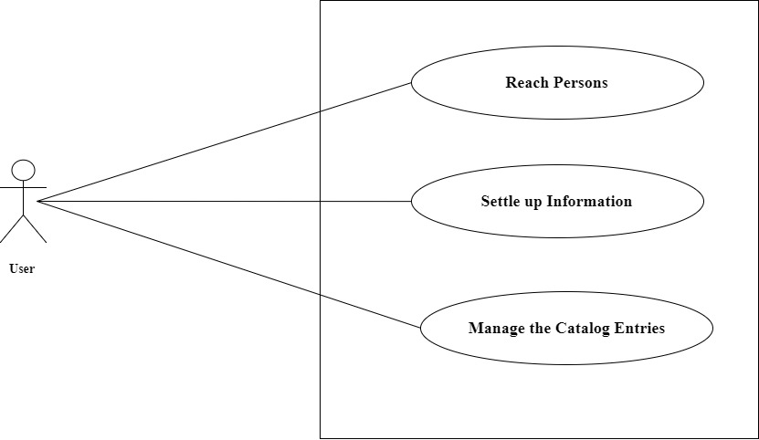

Figure 1: Use Case diagram of address book system

## Actor Goal List

|  |  |
| --- | --- |
| Actor | Goal |
| 1. User or Admin | 1. Gather all possible information 2. Sum up all the information 3. Create a new profile 4. Edit profile 5. Update profile 6. Delete profile |

## Use Case Description

## Reach Persons

|  |  |  |
| --- | --- | --- |
| Scope | Address Book System | |
| Level | User Goal | |
| Actor | User or Admin | |
| Description | User should conduct with persons to add them in the system. User should collect the person’s details and gather them along. | |
| Precondition | 1. User must meet with persons. 2. Every record must contain person’s first name, last name, address, city, state, zip & phone number. | |
| Post Condition | 1. Contact with people must be happened. 2. Person’s details must be invented. | |
| Main Success Scenario | Actor | System |
| 1. Successfully reach the people 2. Person’s details successfully gathered in the system. | * 1. Freeze all details. |
| Failure Scenario | 1. User might not reach the persons and could not gathered enough information. | |

## Settle up Information

|  |  |  |
| --- | --- | --- |
| Scope | Address Book System | |
| Level | User Goal | |
| Actor | User or Admin | |
| Description | Settle up the information in the system sequentially first name or last name, zip code, address, city, state and phone number. | |
| Precondition | 1. Person must have their first name or last name. 2. Person must have a valid address. | |
| Post Condition | 1. Persons should provide their first name or last name. 2. Person should give their all possible information. | |
| Main Success Scenario | Actor | System |
| 1. Persons have to add successfully according to first name or last name. 2. Request to add other details. | * 1. Add persons to their name.   2. Add other details |
| Failure Scenario | 1. If the user can’t be added by their first name or last names and other details all the information might not be settled up properly. | |

## Handle Address Book

|  |  |  |
| --- | --- | --- |
| Scope | Address Book System | |
| Level | User Goal | |
| Actor | User or Admin | |
| Description | It should be concerned to create a new address book, open existing file and update book. The systems file menu will also have a quit option to allow closing all open address and terminate the program. | |
| Precondition | 1. Current address book must have changed as the last successful New, Open, Save or Save as operation has done. 2. User should not cancel the operation. | |
| Post Condition | 1. User should save the new entry. | |
| Main Success Scenario | Actor | System |
| 1. User request to create a save change. 2. Request to add new information. | * 1. Save all changes.   2. Add new information. |
| Failure Scenario | 1. System can’t add new information and it would be uncertain. | |

## System Sequence Diagram

## Reach Persons

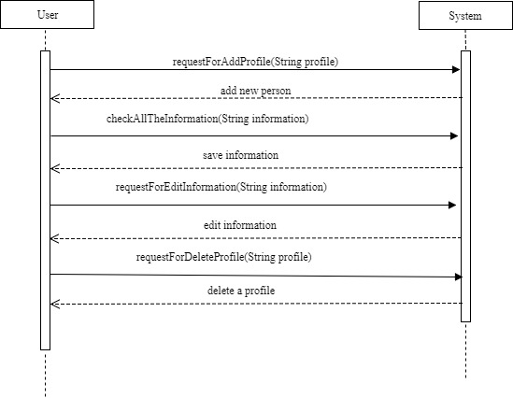

Figure 2: System Sequence diagram of address book system.

## Settle up Information

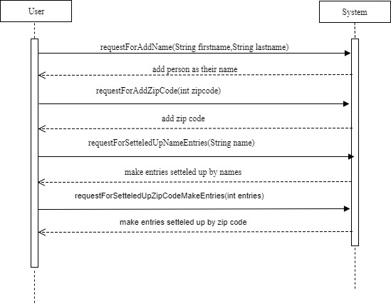

Figure 3: System Sequence diagram of address book system.

## Handle Address Book

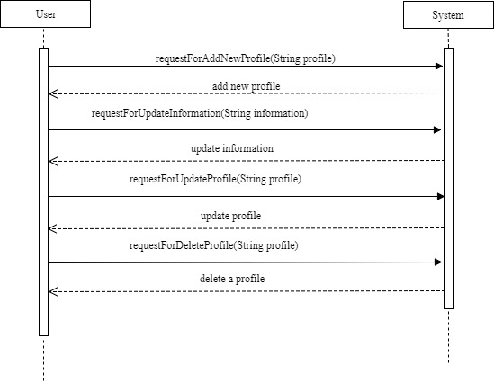

Figure 4: System Sequence diagram of address book system.

## Domain or Conceptual model diagram

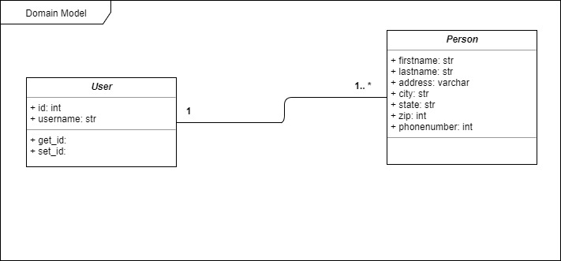

Figure 5: Domain or Conceptual diagram of address book system.

## Activity diagram

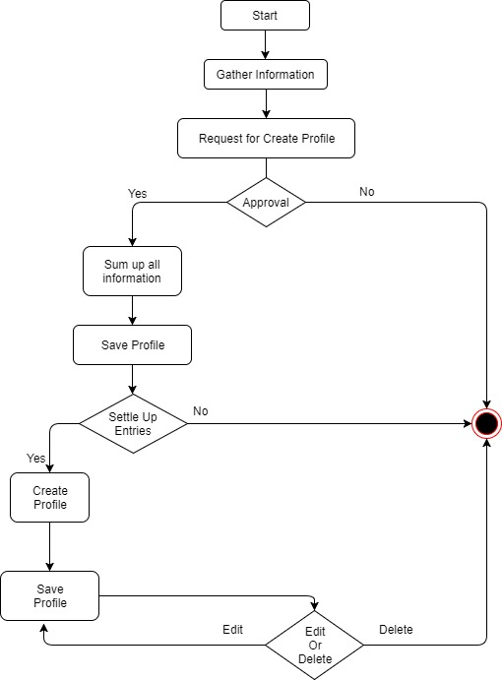

Figure 6: Activity diagram of address book system.

*Chapter 3*

***System Design***

# **System Design**

Design is a process that uses the product of analysis to produce a specification for implementing a system. Design is the logical description of how a system will work.

Design emphasizes a conceptual solution that fulfills the requirements, rather than its implementation. For example, a description of a database schema and software objects. Design ideas often exclude low-level or "obvious" details obvious to the intended consumers. Ultimately, designs can be implemented, and the implementation (such as code) expresses the true and complete realized design. The term is best qualified, as in object-oriented design or database design.

## Sequence Diagram

The UML includes interaction diagrams to illustrate how objects interact via messages. They are used for dynamic object modeling.

## Manage the System

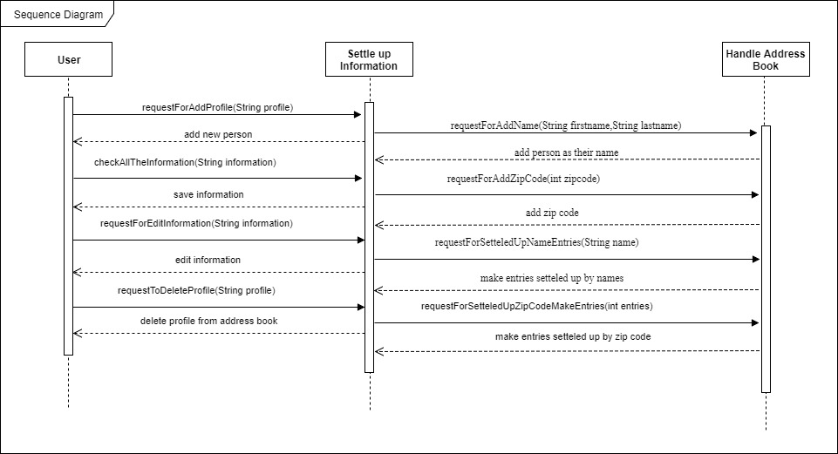

Figure 7: Sequence Diagram of address book system.

## Class Diagram

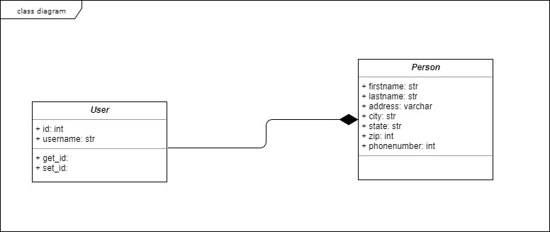

Figure 8: Class diagram of address book system.

*Chapter 4*

***Implementation***

# **Implementation**

Implementation perspective describes software implementations in a particular technology (such as php).Implementation means programming and building the system, not deploying it.

In the implementation phase, the developer builds the components either from scratch or by composition given the architecture document from the design phase and the requirement document from the analysis phase. The architecture document should give guidance.

## Tools and Technologies

* Following are the tools and technologies used in development of this project:
* PHP
* My SQL
* Atom
* XAMPP
* HTML5, CSS, JavaScript, J-query, Twitter bootstrap

## Project Link

https://github.com/saifjewel/ABS05